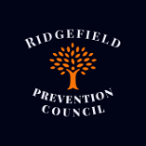

**Ridgefield Prevention Council**

**June 25, 2024, 7:00pm**

**Town Hall, Annex**

Mission: The Ridgefield Prevention Council supports a safe and healthy environment for all Ridgefield families through awareness, education and positive alternatives to alcohol and other substance use and to reduce high-risk youth behaviors

 "Ridgefield Prevention Council meetings will be conducted under Roberts Rules of Order and all participants are expected to conduct themselves with dignity and treat all those present with respect, empathy and civility."

**Call to Order**

**Guests: Rudy Marconi**

**Approval of Minutes:** May

**Treasurer report:** Karen

**Reports/Discussion:**

* Concerns about the future of RPC
* Monthly Calendar for 24-25 year
* Summer Events/Plans

**New Business:**